**RESUME**

**Charan Srinivas Karothi** 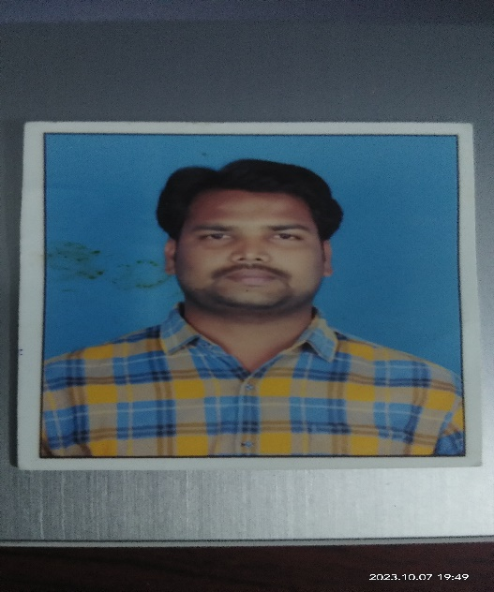

**Kommineni Towers,**

**Kukatpally,**

**Hyderabad,**

**Telangana.**

**Mobile: +91-8886144143**

**E-mail :Karothicharansrinivas@gmail.com**

**______________________________________________________________________________**

**objectives**

**I am a self-motivating and quality conscious person and my key attributes are firm determination, innovative ideas, positive attitude, never dying confidence and diligence.**

**ACADAMIC QUALIFICATION :**

|  |  |  |  |
| --- | --- | --- | --- |
| Qualification | Institute | Year | Performance |
| **Intermediate (M.P.C)** | **P.B Siddhartha Junior College of Arts&Scince** | **2009-2011** | **Discontinue** |
| **10th class** | **Vivekananda Centinary High School** | **2012** | **50%** |

**Strengths:**

* **Confident, self-learning and hard working.**
* **Ability to quickly grasp professional aspects and willingness to learn.**
* **Confidence to face new challenges.**
* **Positive Attitude**

**Experience:**

* **Work as a Dance Teacher at Nalanda High School, at Vijayawada**

**Personal Details :**

**Name : K. Charan Srinivas**

**FATHER NAME : K. Satyanarayana**

**Nationality : Indian,**

**D.O.B : 28-04-1995,**

**Marital Status : Singal,**

**Mother Tongue : Telugu,**

**Languages known : Telugu, English,**

**ADDRESS : K. Satyanarayana,**

**F no-403 Kommineni Towers,**

**Kukatpally, KPHB 6th  Phase ,**

**Hyderabad, Telangana,**

**PIN: 500085.**

**DECLARATION :**

**I Hereby Declare That The Above-Mentioned Information Is Correct Up To My Knowledge And I Bear The Responsibility For The Correctness Of The Above-Mentioned Particulars.**

**Place : Kukatpally, Hyderabad.**

**Date :**

**Signature**